Integrated Geochemical Interpretation Ltd
The Granary, Hallsannery, Bideford, Devon, EX39 5HE, UK

Tel: +44 (0) 1237 471749, Fax: +44 (0) 1237 421700
E-mail: info@igiltd.com
Website: www.igiltd.com

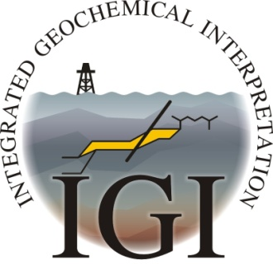
TRAINING COURSE BOOKING FORM

5 day Petroleum Geochemistry and Basin & Petroleum Systems Modelling training courses to be held in May 2019 at IGI Ltd, The Granary, Hallsannery, Bideford, Devon, UK

NAME:

COMPANY:

ADDRESS:

TEL:

TEL (Mobile):

Email:

Any special requirements:

Please indicate which course you wish to attend.
5-day Basin & Petroleum Systems Modelling 13 – 17 May 2019 Monday to Friday

5-day Petroleum Geochemistry 20 – 24 May 2019 Monday to Friday

The cost for the full 5-day training course is £2600.00

Please note: IGI Ltd does not have a credit card facility These prices include tuition, course notes and lunches

- All prices and fees quoted to the client are exclusive of UK VAT which, where applicable will be charged at the prevailing rate (currently 20%) and added to the invoice.
- Terms of payment are net within thirty days of the date of invoice and will be made in GBP

IGI Ltd cancellation policy for training courses
Should circumstances mean that you have to cancel your place on the course and you are unable to transfer your booking to another date at the time of cancellation, the following charges will apply:
- More than four weeks prior to the course start date - no charge
- Two to four weeks prior to the course - 50% of the course fee
- Less than two weeks prior to the course - full fee.

On occasion, unforeseen circumstances may require us to cancel a course. In such circumstances you will be given as much notice as possible and either a free transfer to another course date or a full refund of course fees paid.

Please return this form to:
Helen Davis, IGI Ltd., The Granary, Hallsannery, Bideford, Devon EX39 5HE, UK.
Tel: +44(0) 1237 471749; Fax: +44(0) 1237 421700; email: helendavis@igiltd.com

